Project Design Phase-II
Data Flow Diagram & User Stories

Date | 5 July 2026
Team ID | SWTID-2026-6724
Project Name | Plugging Into the Future: An Exploration of Electricity Consumption Patterns
Maximum Marks | 4 Marks

Team: Dharshini Priya S, Thanusha Peneti, Yogananda Reddy Chinnannagari, Mudiyala Shashank Reddy
Data Flow Diagrams:
A Data Flow Diagram (DFD) is a traditional visual representation of the information flows within a system. A neat and clear DFD can depict the right amount of the system requirement graphically. It shows how data enters and leaves the system, what changes the information, and where data is stored.

Example: (Simplified)



Our Data Flow:
Raw Data Sources (CSV / government energy portals) → Data Ingestion Scripts → Data Cleaning & Transformation (handling missing values, unit standardization) → Tableau Data Source → Interactive Dashboards → End Users (analysts, planners, the public).
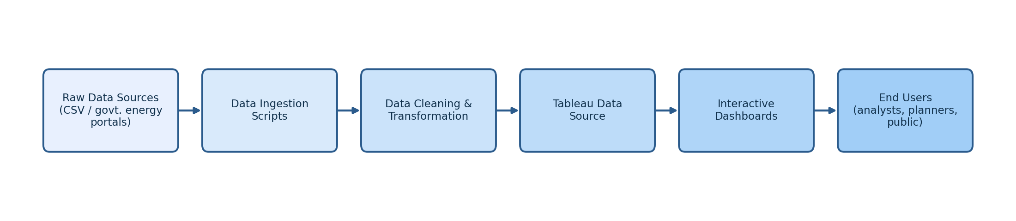
User Stories
Use the below template to list all the user stories for the product.
User Type | Functional Requirement (Epic) | User Story Number | User Story / Task | Acceptance criteria | Priority | Release
Energy Analyst | Registration | USN-1 | As a user, I can register for the application by entering my email, password, and confirming my password. | I can access my account / dashboard | High | Sprint-1
Energy Analyst | Registration | USN-2 | As a user, I will receive a confirmation email once I have registered. | I receive a confirmation email and can click confirm | High | Sprint-1
Energy Analyst | Login | USN-3 | As a user, I can log into the application by entering email & password. | I can access the dashboard after correct login | High | Sprint-1
Energy Analyst | Dashboard | USN-4 | As a user, I can view monthly and seasonal electricity consumption trends. | I can see curated trend charts by month/season | High | Sprint-2
Energy Analyst | Regional Comparison | USN-5 | As a user, I can filter and compare consumption across states/regions. | Filtered charts update by region selection | High | Sprint-2
Web User | Report Export | USN-6 | As a user, I can export a chart or summary as a report. | Downloaded report matches on-screen view | Medium | Sprint-3
Support Executive | Query Handling | USN-7 | As a support exec, I can view and reply to user queries submitted through the contact form. | I can reply to inquiries and see resolution status | Medium | Sprint-3
Administrator | Data Management | USN-8 | As an admin, I can upload/update the electricity consumption dataset. | Dashboard reflects updated data after refresh | High | Sprint-2

